**Technology Recovery Plan**

**(Leidsche, Recovery Exercise)**

**Version .01**

**August 22, 2019**

Contents

Approvals and Signatures 2

Coordinator Information 3

Exercise Initiation 3

Support Team Members 4

Recovery steps performed by RGA Windows Administration team 4

CA1 iSeries DR Instructions 5

Leidsche IT and Business instructions for entering the CA1 DR environment 6

Exercise Completion 12

Full Site Failure – Not Exercise Related. 12

Conduct DR failover for Operation at DR Site 12

Primary Site Restoration & Resumption of Replication Operations 12

Appendices 14

Recovery Site Location 14

Primary Site Contacts 14

Alternate Site Contacts 14

Document History and Change Management Table 15

Instructions for Version Control: 15

# Approvals and Signatures

|  |  |  |  |
| --- | --- | --- | --- |
| Business Unit | Management Name | Date of Approval | Signature |
| Application Support | Ivar Post |  |  |
| Service Continuity | Jim O’ Shea |  |  |
| Business Continuity | Michael Keating |  |  |
| Head IT - Leidsche | Elgar Bos |  |  |
|  |  |  |  |

# 

# Coordinator Information

* Service Continuity Director: Jim O’Shea
* Business Continuity Management: Mike Keating and Steve Seton
* Data Center Services (WinSys, Unix, Linux, Storage): Mike Quinn
* Infrastructure Applications (Database, SQL, Web & Framework) Bill McCrary
* Unified Communication: Spencer Readman
* Leidsche Operations and Business Coordination: Ivar Post
* Leidsche IT Management: Elgar Bos

# Exercise Initiation

1. Leidsche’s exercises are planned
2. The Disaster Recovery team establishes a “virtual war room” with the following bridge line **1-636-736-8887, 4799349#.** All contacted resources will call into the bridge, discuss the event, and commence with the exercise or required task within the recovery plans:
   1. The **Windows Administration Support** assignee coordinates with the Leidsche team to begin the recovery process using the instructions in this plan.
   2. The Leidsche assignees notify the business and coordinate the preparation of the DR workstations.
3. Once the DR exercise is initiated, the bridge line is closed, and the use of WhatsApp is the primary source of communication between IT, Disaster Recovery, and the Leidsche team.
   1. The RGA bridge line and Skype may be used if additional methods of communication with RGA IT support resources; i.e. UNIX, DBA’s Infosec, etc. are required.
4. A list of support team members and their contacts are below, or on the next page.

## Support Team Members

* Disaster Recovery Team (or Service Continuity): Richard Jurado (mobile1) 1-951-751-5616, (mobile2) 636-686-8137, Jim O’Shea (mobile) 314-580-1848, Jim Elkins (mobile) 314-229-3819
* Security On-Call: Firewall configuration. Security On Call number; 636 736 8827
* UNIX On Call: Modify IP Addresses. The on-call number is 636 736 5890
* Oracle On-Call: Configure TNSListener. DBA oncall number is 636-736-5377.
* Bridge Line: 1-636-736-8887 Code: 4799349#

## Recovery steps performed by RGA Windows Administration team

The procedures outlined in this section provide the steps needed to perform a failover (recovery) of system operations using Zerto replication. IT resources are staged and identified in the steps as to when they are required to perform a process.

1. The Windows admin team member contacts storage the day before the exercise is to begin to get the ID for the appropriate ‘snapshot ‘ of the Leidsche environment to restore into the CA1 datacenter DR environment.
2. The date/timestamp is provided to the RGA iSeries resource, by the storage team, for the appropriate time to cease MIMIX replication between the UK1 datacenter iSeries server and the CA1 iSeries server.
3. The iSeries resource schedules the replication pause based on the date and time provided by the storage team.
4. Based on the ID provided by storage the Winsys resource presents the snapshot in the CA1 DR environment and starts the servers in the order provided in the list below.

|  |  |  |
| --- | --- | --- |
| **Name** | **Location** | **Sequence of startup** |
| iSeriesCA1 | CA1 | 0 |
| uk1psexigraf01 | CA1 | 0 |
| SQL-01 | CA1 | 1 |
| SQL-02 | CA1 | 2 |
| SQL-03 | CA1 | 3 |
| SQL-04 | CA1 | 4 |
| SQL-05 | CA1 | 5 |
| SQL-06 | CA1 | 6 |
| ACC-01 | CA1 | 7 |
| ACC-02 | CA1 | 8 |
| AS-02 | CA1 | 9 |
| AS-03 | CA1 | 10 |
| AS-04 | CA1 | 11 |
| AS-05 | CA1 | 12 |
| DC-03 | CA1 | 13 |
| DC-04 | CA1 | 14 |
| FP-01 | CA1 | 15 |
| FP-02 | CA1 | 16 |
| NAV-01 | CA1 | 17 |
| NAV-02 | CA1 | 18 |
| PPC-01 | CA1 | 19 |
| PPC-02 | CA1 | 20 |
| RDSAB-01 | CA1 | 21 |
| RDSGW-01 | CA1 | 22 |
| RDSLV-01 | CA1 | 23 |
| Web-02 | CA1 | 24 |
| RDSLV-02 | CA1 | 25 |
| Web-03 | CA1 | 26 |
| RDSLV-03 | CA1 | 27 |
| RDSLV-04 | CA1 | 28 |
| RDSLV-05 | CA1 | 29 |
| RDSLV-06 | CA1 | 30 |
| rdslv-clone | CA1 | 31 |
| VAR-01 | CA1 | 32 |
| TST-01 | CA1 | 33 |
| TST-02 | CA1 | 34 |
| DEV-01 | CA1 | 35 |
| DEV-02 | CA1 | 36 |
| DEV-03 | CA1 | 37 |

1. The Leidsche IT and business resources follow the below instructions in order to enter the CA1 DR environment:

## CA1 iSeries DR Instructions

Failover iSeries server UK1PLVM1 to DR system CA1DRLVM

- contact Syncsort to perform Mimix Role Swap procedure

Primary contact: Fred Grunewald 949-253-6512

MIMIX Customer Support: 800-337-8214

- add autostart job to qbatch subsystem

ADDAJE SBSD(QSYS/QBATCH) JOB(PAXUSAJE) JOBD(PAXUS/PAXUSAJE)

- run application startup cl program

DJHADMIN2/STRAPPSBS

## Leidsche IT and Business instructions for entering the CA1 DR environment

Use Internet Explorer as browser. Otherwise, the message below is displayed and the exercise cannot continue until IE is launched.

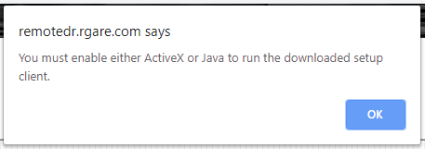

Open browser and go to <https://remotedr.rgare.com/LVM>

* 1. If the message blelow is displayed, someone with Administrator authority is required to log in and download the required software. Ideally, this would have been done prior to the exercise on all devices used in the exercise.

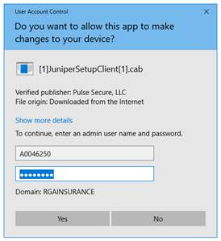

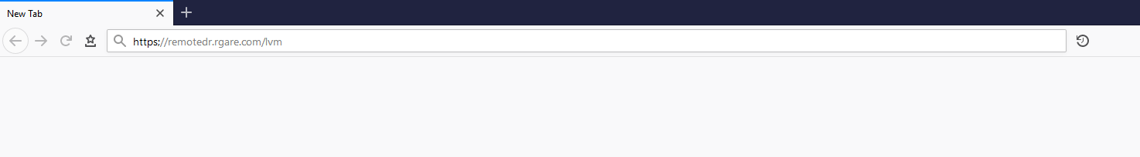

* 1. Enter in RGAInsurance username and password on the screen illustrated on the next page.

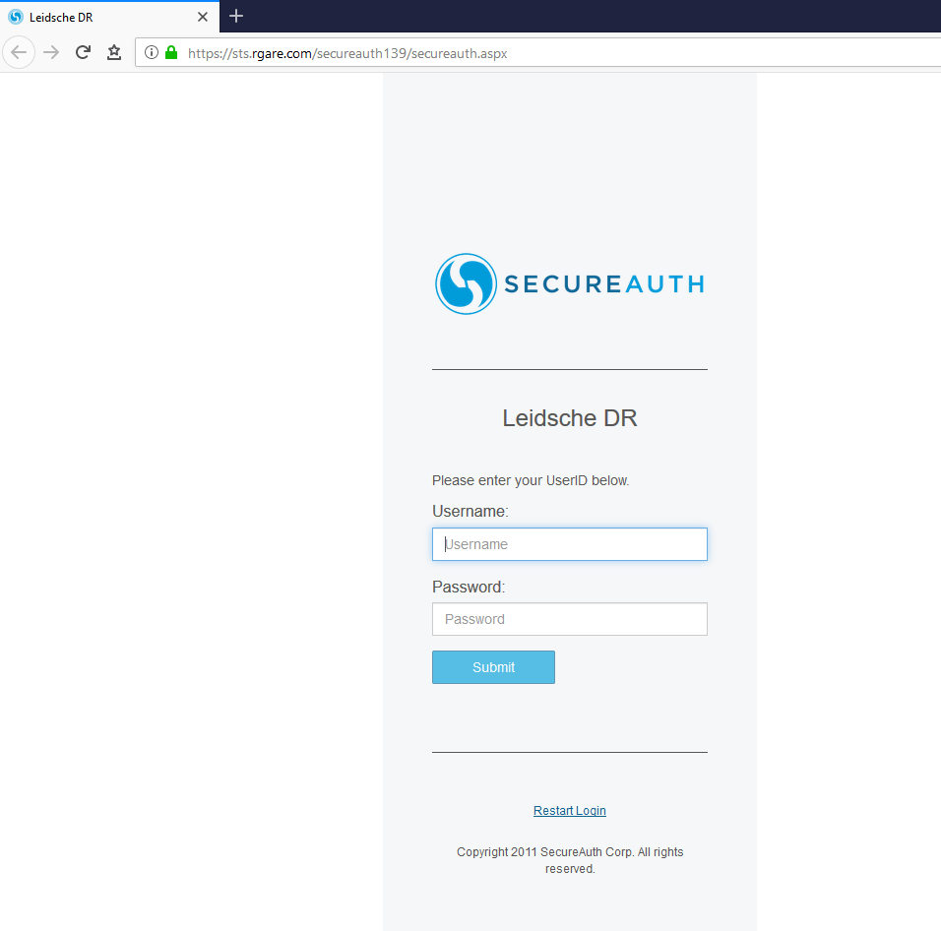

* 1. The Leidsche DR home page is displayed offering links to Leidsche remote desktop servers
  2. Click the link of one of the servers to connect to the DR environment.

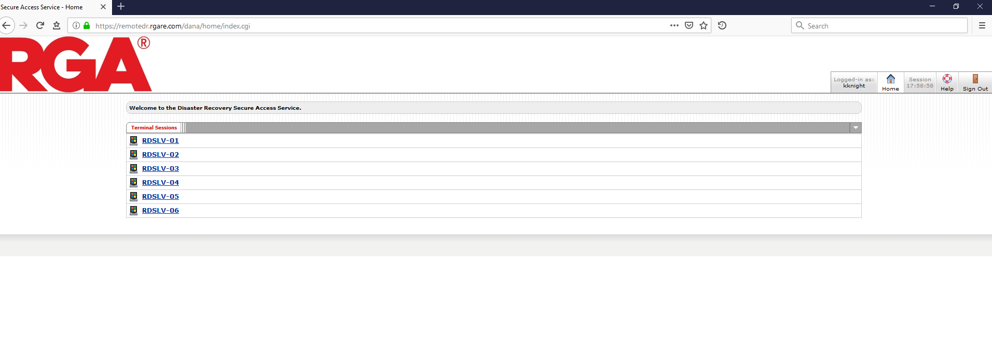

* 1. When finished with the session please click Sign Out to disconnect.



* 1. After disconnecting please close the browser

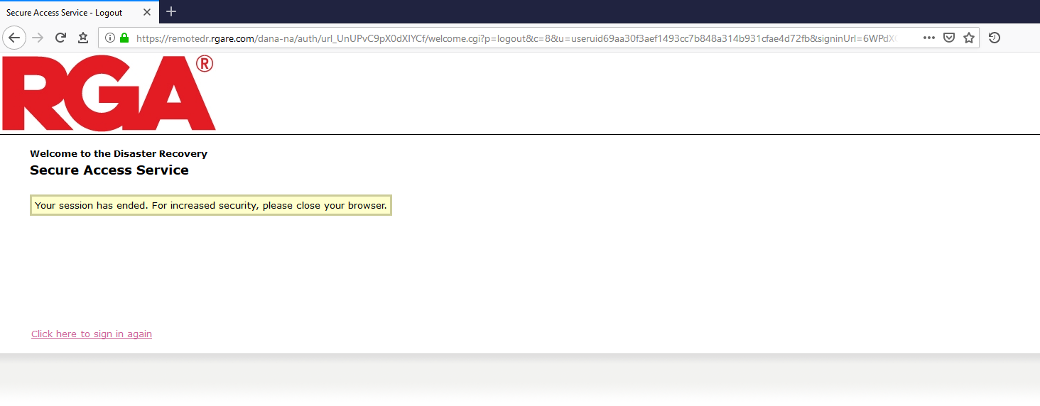

1. **At this point the Leidsche business verification can be conducted in the CA1 DR environment as it is conducted in the production environment running out of the UK1 datacenter.**
2. **The logging template on the following page is used to record the applications verified in the exercise.**

|  |  |  |  |  |
| --- | --- | --- | --- | --- |
|  | **Application** | **Green/Yellow/Red** | **Owner** | **Test findings** |
| A.01 | LiFE400 (A.01) | **Passed** | Albert van Deudekom |  |
|  | Ledger module | **Passed with issues** | Timo Gerrits |  |
| A.03 | Beleggingsadministratie (A.03) | **Failed** | Casper van der Salm |  |
| A.08 | FOP (A.08) |  | Albert van Deudekom |  |
| A.10 | Printprogramma (A. 10) batch |  | Eric van den Broek |  |
| A.14 | Offerte onderhoud (A.14) |  | Albert van Deudekom |  |
| A.15 | LVM Enquiry (A.15) Web |  | Hans Fransen |  |
|  | LVM EnquiryAS400Data batch |  | Hans Fransen |  |
| A.16 | LVM Letters (A.16) |  | Albert van Deudekom |  |
| A.18 | Nachtprogramma (A. 18) batch |  | Annemieke Hartendorp |  |
| A.19 | Polis prognoses |  | Annemieke Hartendorp |  |
| A.20 | Rekening Courant |  | Timo Gerrits |  |
| A.21 | Taskrun (A.21) batch |  | Eric van den Broek |  |
| A.25 | Xtendis (A.25) Web |  | Albert van Deudekom |  |
| A.28 | LVM Direct (A.28) Web |  | Hans Fransen |  |
| A.34 | Corporate website (A. 34) Web |  | Hans Fransen |  |
|  | AB Portaal (A.34) Web |  | Hans Fransen |  |
| A.35 | Offerteapplicatie (A. 35) |  | Hans Fransen |  |
| A.36 | Dividend400 (A.36) |  | Casper van der Salm |  |
| A.37 | LIFE400ClntsDBF (A.37) batch |  | Eric van den Broek |  |
| A.41 | Bizmedic (A.41) Web |  | Saskia Versluis |  |
| A.42 | BizActivering Web |  | Hans Fransen |  |
| A .43 | BizPropeller Web |  | Hans Fransen |  |
| A.44 | MS Dynamics/NAV |  | Casper van der Salm |  |
| A. 45 | DataPomp batch |  | Eric van den Broek |  |
|  | ADP (wordt extern) |  | Casper van der Salm |  |
| A. 48 | JetMail (Extern) |  | Albert van Deudekom |  |
| A. 49 | ABN AMRO/RABO online banking |  | Timo Gerrits |  |
| A. 50 | VP/MS |  | Annemieke Hartendorp |  |
| A. 51 | PlanetPress Connect |  | Albert van Deudekom |  |
| A. 52 | Logius (reseignering, Extern) |  | AIbert van Deudekom |  |
| A.53 | LVM ABZ-Webservice (Extern wwft) |  | AIbert van Deudekom |  |
| A.55 | CDDN (Extern via ftp) |  | AIbert van Deudekom |  |
| A.56 | PLSHistorie |  | Albert van Deudeko |  |
| A. 57 | Bereken VVP |  | Annemieke Hartendorp |  |
| A. 58 | Prophet |  | Annemieke Hartendorp |  |
|  | EY portal |  | Timo Gerrits |  |
|  | Accesstool EY |  | Timo Gerrits |  |
|  | Koerscontrole Excel |  | Timo Gerrits |  |
| A.59 | ZIVVER |  | Elgar Bos |  |
|  | RDP |  | Elgar Bos |  |
|  | Office365/ Sharepoint |  | Elgar Bos |  |
|  | Visio |  | Elgar Bos |  |
|  | Internet Explorer |  | Elgar Bos |  |
|  | Chrome |  | Elgar Bos |  |
|  | Adobe Reader |  | Elgar Bos |  |
|  | CutePDF (PDF printer) |  | Elgar Bos |  |
|  | Citrix (Theodor Gielsen) |  | Timo Gerrits |  |
|  | Picture Picker (PicPick) |  | Elgar Bos |  |
|  | Greenshot |  | Elgar Bos |  |
|  | .Net Framework |  | Elgar Bos |  |
|  | Spindle |  | Casper van der Salm |  |
|  | Skype for Business |  | Elgar Bos |  |
|  | 7zip |  | Elgar Bos |  |
|  | KeePass |  | Elgar Bos |  |
|  | Postcode tabel |  | Elgar Bos |  |
|  | Visual studio |  | Elgar Bos |  |
|  | Delphi |  | Elgar Bos |  |
|  | Kentico |  | Elgar Bos |  |
|  | Notepad++ |  | Elgar Bos |  |
|  | SQL server 2008 |  | Elgar Bos |  |
|  | Teamviewer |  | Elgar Bos |  |
|  | Onetastic |  | Elgar Bos |  |
|  | Spacesniffer |  | Elgar Bos |  |
|  | WinMerge |  | Elgar Bos |  |

Exercise Completion

Performed by the Leidsche and STL teams

1. After users/owners have confirmed all their applications are working properly and the recovery test has been deemed complete, all users log off their terminal server connection and log off or power down the workstations.

CA1 iSeries shutdown

1. Contact Syncsort to perform Mimix replication restart

Primary contact: Fred Grunewald 949-253-6512

MIMIX Customer Support: 800-337-8214

1. Remove autostart job from qbatch subsystem on CA1 iSeries - CA1DRLVM

ADDAJE SBSD(QSYS/QBATCH) JOB(PAXUSAJE) JOBD(PAXUS/PAXUSAJE)

1. End all applications started via application startup cl program:

DJHADMIN2/STRAPPSBS

# Full Site Failure – Not Exercise Related.

## Conduct DR failover for Operation at DR Site

Perform the activities described above through page 13 to resume IT operations at the alternate site – CA1.

* Once all systems, applications, and workstations are recovered and fully integrated with the RGA production network, business operations can resume from the recovery site which becomes the primary site.

# Primary Site Restoration & Resumption of Replication Operations

Perform the following activities to restore services at the primary site or new secondary site location.

1. Based on the results of the damage assessment, Leidsche personnel contact RGA IT to begin replacement planning of infrastructure, environmental, and computing resources.
2. Contact vendors to begin replacement of hardware and software. Coordinate with the RGA IT as necessary.
3. Once primary site infrastructure and network and computing resources are available, begin configuration and staging of systems to be recovered.
4. Restore Leidsche environment at new secondary location, CA1 will continue as the primary location
5. Upon completion of restorations, verify all applications are functioning normally.
6. Resume primary site operations at CA1 – backups, etc.

# Appendices

# Recovery Site Location

The following is a list of primary data and operational center and alternate recovery sites in connection with RGA IT DR.

## Primary Site Contacts

|  |  |  |  |  |
| --- | --- | --- | --- | --- |
| Facilities Name | | Street Location | City / State / Zip | Support |
| Leidsche Verzekering Maatschappij N.V. | | Quinterium Offices Gebouw I | Kampenringweg 45-A  Postbus 11  2800 AA Gouda |  |
| Contact Person | | **Phone Number/Email** | **Alternate Contact** | **Phone Number/Email** |
| Elgar Bos | +31 (6) 10110535 | | Ivar Post | ipost@leidsche.nl |

## Alternate Site Contacts

|  |  |  |  |  |  |  |
| --- | --- | --- | --- | --- | --- | --- |
| Facilities Name | | Street Location | | City / State / Zip | Support | |
| **RGA Life Reinsurance Company of Canada** | | 1981 McGill College Avenue, 13th Floor | | Montréal, Québec H3A 3A8 Canada | **T** 514.985.5260 **F** 514.985.3066 **Toll-Free:** 1.800.985.4326 | |
| Contact Person | | **Phone Number** | | **Alternate Contact** | **Phone Number** | |
| Bazelais Zephyr | +1 (514) 985-6468 | | Spencer Readman | | | +1 (416) 682-0029 |

# 

# Document History and Change Management Table

The author or assigned analyst will update this plan and gain approval for any major changes to the plan, and must be approved by the Service Continuity Director.

## Instructions for Version Control:

* First Draft is listed as “0.1” with subsequent drafts increasing by “0.1” until final draft is approval to be the first final version.
* Final Version will be listed as “1.0”.
* Revisions to a Final Version. First revision will be noted as “x.1”, with subsequent drafts increasing by “0.1”, e.g. 1.1, 1.2, 1.3
* Subsequent Finals. Version number will increase by “1.0” above the version be revised, e.g. 1.x becomes “2.0”, “2.0 becomes 3.0”

|  |  |  |  |  |  |
| --- | --- | --- | --- | --- | --- |
| Version | Document Changes/Sections | Author/Title | Changes | Date | Approvals |
| 0.1 | Revised Plan | Jim Elkins | Initial Plan | 8/22/2019 |  |
|  |  |  |  |  |  |
|  |  |  |  |  |  |
|  |  |  |  |  |  |
|  |  |  |  |  |  |
|  |  |  |  |  |  |
|  |  |  |  |  |  |
|  |  |  |  |  |  |
|  |  |  |  |  |  |
|  |  |  |  |  |  |
|  |  |  |  |  |  |
|  |  |  |  |  |  |
|  |  |  |  |  |  |
|  |  |  |  |  |  |